Insert Anggota

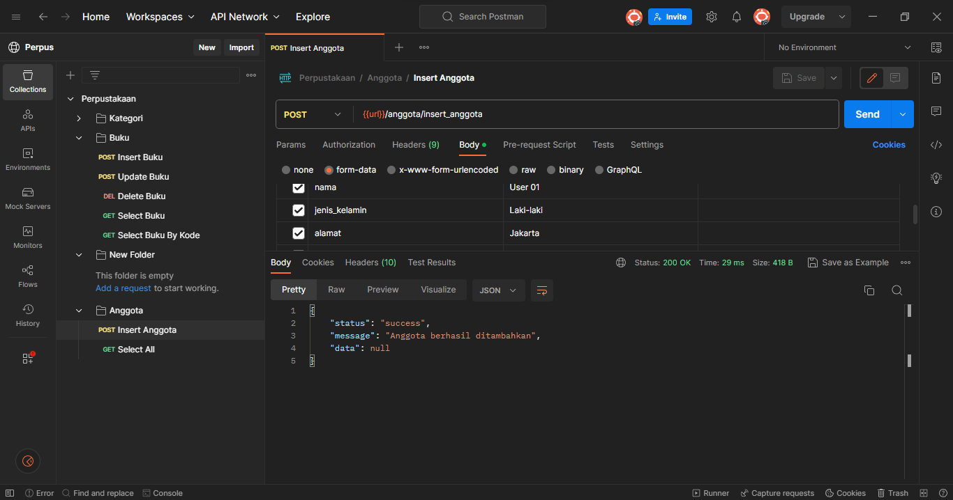

Select All

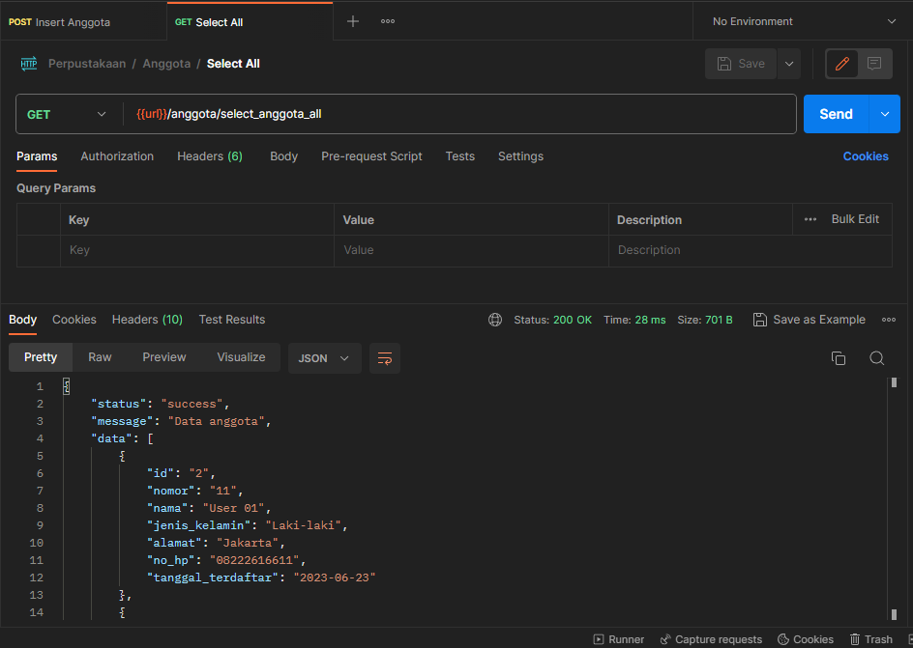

Edit

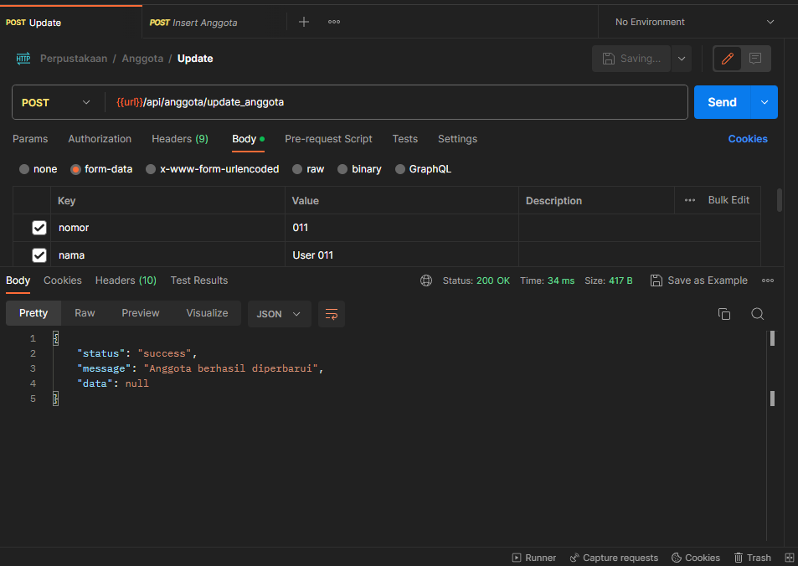

Select by nomor  
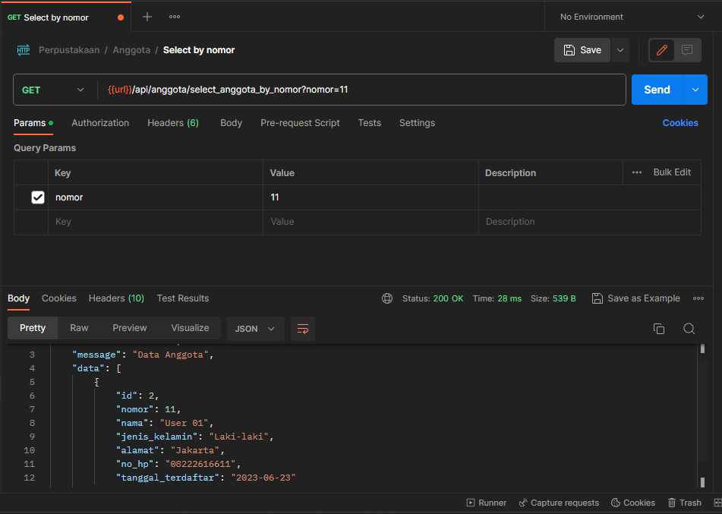

Delete   
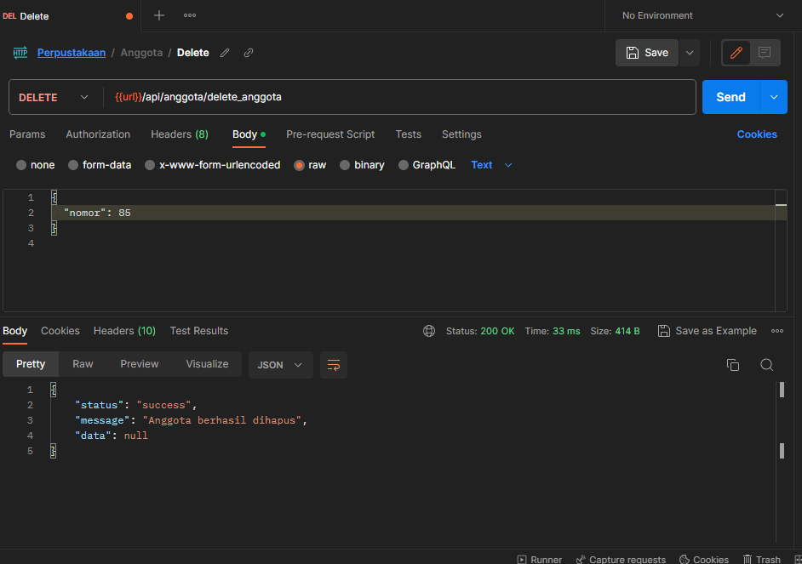

Web Index Anggota  
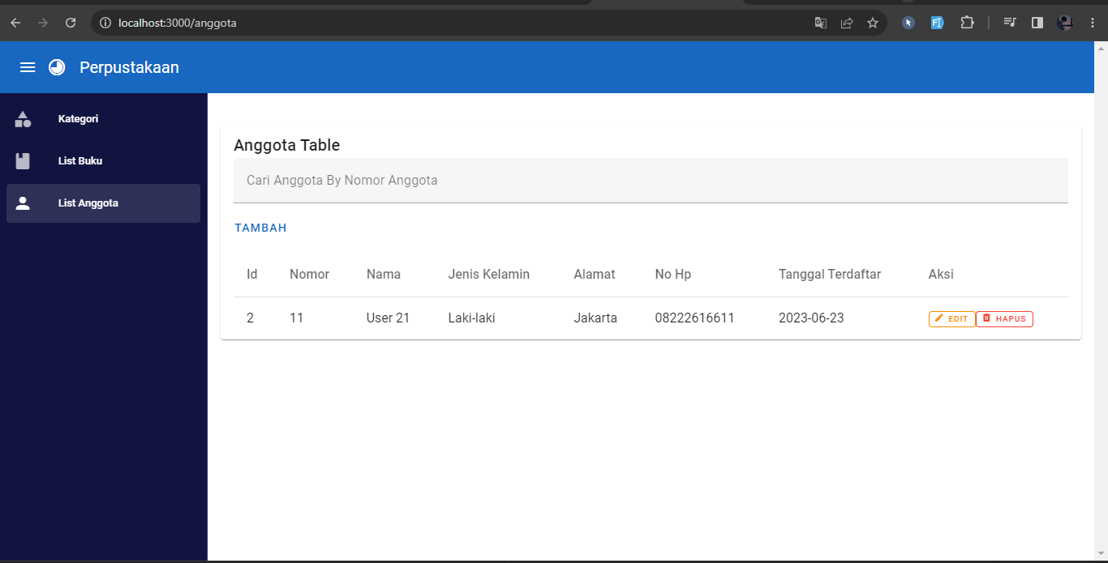

Insert Anggota

Update Anggota

Delete Anggota

